 

# DESIGN AND FABRICATION OF SIMPLE PORTABLE WATER FILTER

**A MINOR PROJECT REPORT**

*Submitted by*

**V.VISHNUVISHAL (927622BME103)**

**K.VISHVA PRIYAN (927622BME104)**

**R.YAGESHRAJ (927622BME105)**

***in partial fulfillment for the award of the degree***

***of***

**BACHELOR OF ENGINEERING**

**IN**

**MECHANICAL ENGINEERING**

**M. KUMARASAMY COLLEGE OF ENGINEERING, KARUR**

**ANNAUNIVERSITY: CHENNAI 600025**

**NOVEMBER 2023**

 

# DESIGN AND FABRICATION OF SIMPLE PORTABLE

**WATER FILTER**

**A MINOR PROJECT REPORT**

***Submitted by***

**V.VISHNUVISHAL (927622BME103)**

**K. VISHVA PRIYAN (927622BME104)**

**R. YAGESHRAJ (927622BME105)**

***in partial fulfillment for the award of the degree of***

**BACHELOR OF ENGINEERING**

***in***

**MECHANICAL ENGINEERING**

**M. KUMARASAMY COLLEGE OF ENGINEERING, KARUR**

**ANNA UNIVERSITY: CHENNAI 600025**

**NOVEMBER 2023**

# M. KUMARASAMY COLLEGE OF ENGINEERING, KARUR

**BONAFIDE CERTIFICATE**

Certified that this project report “**DESIGN AND FABRICATION OF SIMPLE PORTABLE WATER FILTER** is the bonafide work of **“V. VISHNU VISHAL (927622BME103), K. VISHVA PRIYAN (927622BME104), R. YAGESHRAJ**

**(927622BME105)”** who carried out the project work during the academic year 2023 – 2024 under my supervision. Certified further, that to the best of my knowledge the work reported here in does not form part of any other project report or dissertation based on which a degree or award was conferred on an earlier occasion on this or any other candidate.

|  |  |
| --- | --- |
| **SIGNATURE** | **SIGNATURE** |
| Mr. M. DHIVYANATHAN M.E | Dr. M. Loganathan M.E., Ph.D., |
| **SUPERVISOR** | **HEAD OF THE DEPARTMENT** |
| Department of Mechanical Engineering, | Department of Mechanical Engineering, |
| M. Kumarasamy College of Engineering, | M. Kumarasamy College of Engineering, |
| Thalavapalayam, Karur - 639113. | Thalavapalayam, Karur - 639113. |

This project report has been submitted for the end semester project viva voce Examination held on

INTERNAL EXAMINER EXTERNAL EXAMINER

DECLARATION

We affirm that the Project titled **“DESIGN AND FABRICATION OF SIMPLE PORTABLE WATER FILTER** submitted in partial fulfillment off or the End Semester Examination of **B.E. MECHANICAL ENGINEERING**, is the original work carried out by us. It has not formed the part of any other project or dissertation based on which a degree or award was conferred on an earlier occasion on this or any other candidate.

Student Name Signature

1. V.VISHNUVISHAL ---------------------------
2. K. VISHVA PRIYAN ---------------------------
3. R. YAGESHRAJ ---------------------------

Name and signature of the supervisor with date

**ACKNOWLEDGEMENT**

Our sincere thanks to Thiru. M. Kumarasamy, Chairman and Dr. K. Ramakrishnan, B.Secretary of M. Kumarasamy College of Engineering for providing extraordinary infrastructure, which help us to complete the project in time.

It is a great privilege for us to express our gratitude to our esteemed Principal Dr. B.S. Murugan for providing us right ambiance for carrying out the project work.

We would like to thank Dr. M. Loganathan M.E., Ph.D., Head, Department of Mechanical Engineering, for his unwavering moral support throughout the evolution of the project.

We offer our wholehearted thanks to our internal guide Mr. M. Dhivyanathan M.E., Assistant Professor, Department of Mechanical Engineering, for her/his constant encouragement, kind co- operation, valuable suggestions and support rendered in making our project a success.

We offer our wholehearted thanks to our project coordinator Mr.S.Saravanakumar M.Tech., PhD., Department of Mechanical Engineering, for her/his constant encouragement, kind co-operation, valuable suggestions and support rendered in making our project a success.

We glad to thank all the Teaching and Non-Teaching Faculty Members of Department of Mechanical Engineering for extending a warm helping hand and valuable suggestions throughout the project.

Words are boundless to thank Our Parents and Friends for their constant encouragement to complete this project successfully.

**INSTITUTION VISION&MISSION**

**Vision**

* To emerge as a leader among the top institutions in the field of technical education.

**Mission**

* Produce smart technocrats with empirical knowledge who can surmount the global challenges.
* Create a diverse, fully engaged, learner-centric campus environment to provide quality education to the students.
* Maintain mutually beneficial partnerships with our alumni, industry, and professional associations.

**DEPARTMENT VISION, MISSION, PEO, PO & PSO**

**Vision**

* To create globally recognized competent Mechanical engineers to work in multi-cultural environment.

**Mission**

* To impart quality education in the field of mechanical engineering and to enhance their skills, to pursue careers or enter higher education in their area-of-interest.
* To establish a learner-centric atmosphere along with state-of-the-art research facility.
* To make collaboration with industries, distinguished research institution and to become a center of excellence.

**PROGRAMEDUCATIONALOBJECTIVES(PEOS)**

The graduates of Mechanical Engineering will be able to

* PEO1: Graduates of the program will accommodate insightful information of engineering principles necessary for the applications of engineering.
* PEO2: Graduates of the program will acquire knowledge of recent trends in technology and solve problem in industry.
* PEO3: Graduates of the program will have practical experience and interpersonal skills to work both in local and international environments.
* PEO4: Graduates of the program will possess creative professionalism, understand their ethical responsibility, and commit towards society.

**PROGRAM OUTCOMES**

**The following are the Program Outcomes of Engineering Graduates will be able to:**

1. **Engineering knowledge:** Apply the knowledge of mathematics, science, engineering fundamentals, and an engineering specialization to the solution of complex engineering problems.
2. **Problem analysis:** Identify, formulate, review research literature, and analyze complex engineering problems reaching substantiated conclusions using first principles of mathematics, natural sciences, and engineering sciences.
3. **Design / Development of solutions:** Design solutions for complex engineering problems and design system components or processes that meet the specified needs with appropriate consideration for the public health and safety, and the cultural, societal, and environmental considerations.
4. **Conduct investigations of complex problems:** Use research-based knowledge and research methods including design of experiments, analysis and interpretation of data, and synthesis of the information to provide valid conclusions.
5. **Modern tool usage:** Create, select, and apply appropriate techniques, resources, and modern engineering and IT tools including prediction and modeling to complex engineering activities with an understanding of the limitations.
6. **The engineer and society:** Apply reasoning informed by the contextual knowledge to assess societal, health, safety, legal and cultural issues, and the consequent responsibilities relevant to the professional engineering practice.
7. **Environment and sustainability:** Understand the impact of the professional engineering solutions in societal and environmental contexts, and demonstrate the knowledge of, and need for sustainable development.
8. **Ethics:** Apply ethical principles and commit to professional ethics and responsibilities and norms of the engineering practice.
9. **Individual and teamwork:** Function effectively as an individual, and as a member or leader in diverse teams, and in multidisciplinary settings.
10. **Communication:** Communicate effectively on complex engineering activities with the engineering community and with society at large, such as, being able to comprehend and write effective reports and design documentation, make effective presentations, and give and receive clear instructions.
11. **Project management and finance:** Demonstrate knowledge and understanding of the engineering and management principles and apply these to one’s own work, as a member and leader in a team, to manage projects and in multidisciplinary environments.
12. **Life - long learning:** Recognize the need for and have the preparation and ability to engage in independent and life -long learning in the broadest context of technological change.

**PROGRAM SPECIFIC OUTCOMES (PSOs)**

**The following are the Program Specific Outcomes of Engineering Graduates:**

The students will demonstrate the abilities.

* 1. **Real world application:** To comprehend, analyze, design, and develop innovative products and provide solutions for the real-life problems.
  2. **Multi-disciplinary areas:** To work collaboratively on multi-disciplinary areas and make quality projects.
  3. **Research oriented innovative ideas and methods:** To adopt modern tools, mathematical, scientific, and engineering fundamentals required to solve industrial and societal problems.

|  |  |  |
| --- | --- | --- |
| **Course Outcomes** | At the end of this course, learners will be able to: | **Knowledge Level** |
| CO - 1 | Identify the issues and challenges related to industry, society, and environment. | Apply |
| CO - 2 | Describe the identified problem and formulate the possible solutions. | Apply |
| CO -3 | Design / Fabricate new experimental set up/devices to provide solutions for the identified problems | Analyze |
| CO -4 | Prepare a detailed report describing the project outcome | Apply |
| CO - 5 | Communicate outcome of the project and defend by making an effective oral presentation. | Apply |

**MAPPING OF PO & PSO WITH THE PROJECT OUTCOME**

|  |  |  |  |  |  |  |  |  |  |  |  |  |  |  |  |
| --- | --- | --- | --- | --- | --- | --- | --- | --- | --- | --- | --- | --- | --- | --- | --- |
| **Course Outcomes** | **Program Outcomes** | | | | | | | | | | | | **Program Specific Outcomes** | | |
| 1 | 2 | 3 | 4 | 5 | 6 | 7 | 8 | 9 | 10 | 11 | 12 | 1 | 2 | 3 |
| CO – 1 | 3 | 3 | 3 | 3 | 2 | 2 | 2 | 2 | 3 | 3 | 2 | 2 | 3 | 2 | 3 |
| CO – 2 | 3 | 3 | 3 | 3 | 2 | 2 | 2 | 2 | 3 | 3 | 2 | 2 | 3 | 2 | 3 |
| CO – 3 | 3 | 3 | 3 | 3 | 2 | 2 | 2 | 2 | 3 | 3 | 2 | 2 | 3 | 2 | 3 |
| CO – 4 | 3 | 3 | 3 | 3 | 2 | 2 | 2 | 2 | 3 | 3 | 2 | 2 | 3 | 2 | 3 |
| CO – 5 | 3 | 3 | 3 | 3 | 2 | 2 | 2 | 2 | 3 | 3 | 2 | 2 | 3 | 2 | 3 |

**TABLE OF CONTENTS**

|  |  |  |
| --- | --- | --- |
| **CHAPTER NO.** | **CONTENT** | **PAGE NO.** |
|  | **ABSTRACT** |  |
| **1** | **INTRODUCTION** | **2** |
| 1.1 | PROBLEM STATEMENT | 3 |
| 1.2 | OBJECTIVES | 3 |
| **2** | **PROJECT METHODOLOGY** |  |
| 2.1 | EXISTING PROBLEM | 4 |
| 2.2 | PROPOSED SOLUTION | 4 |
| **3** | **CONSTRUTION AND WORKING** |  |
| 3.1 | CONSTRUCTION | 4 |
| 3.2 | WORKING | 5 |
| 3.3 | ADVANTAGES | 5 |
| 3.4 | DISADVAMTAGES | 5 |
| **4** | **SYSTEM SPECIFICATION** |  |
| 4.1 | HARDWARE SPECIFICATION | 6 |
| **5** | **BLOCK DIAGRAM** | **7** |
| **6** | **RESULTS AND DISCUSSION** | **8** |
| **7** | **CONCULSION** | **9** |
| **8** | **COST ESTIMATION** | **10** |

**ABSTRACT**

This report gives an account of various portable water purifiers available for deployment. The objective is to compare different purifiers and determine the suitability of purifiers in

different conditions. The water quality standards and the requirement of a portable purifier is discussed. The purifiers are classified according to the different purification techniques involved. Subsequently the descriptions of different water purifiers are given.

The purifiers are then compared with respect to various attributes. Finally, the optimum purifier characteristics for a rural household especially in times of a calamity are brought out.

**CHAPTER -1 INTRODUCTION**

Portable water purification devices are self-contained, easily transported units used to purify water from untreated sources (such as rivers, lakes, and wells) for drinking purposes. Their main function is to eliminate pathogens, and often also of suspended solids and some unpalatable or toxic compounds.

* 1. **PROBLEM STATEMENT**

Over 748 million people in the world, predominantly belonging to developing countries, did not have access to safe drinking water in the year 2012. Water access, cleanliness, and sanitation are attributed to causing about 3.7% of the worldwide yearly health burden. (Ash bolt, 2004). The Millenium Development Goal No. 7 is to ensure environmental sustainability. The target 7C in this goal is to reduce the percentage of population not having safe drinking water and basic sanitation by 50% within the year 2015 (MDG, 24.10.2014). Most of the problems in water quality is associated with microbial contamination and partly from chemical pollutants (Ash bolt, 2004).

* 1. **OBJECTIVES**

The objectives of the study in point-wise form are as follows.

* To find out issues concerning drinking water
* To determine the standards stipulated for drinking water quality.
* To survey different water purifiers and purification techniques which are already available.
* To describe the portable purifiers by means of the available literature.
* To enlist the desirable qualities of water treatment devices.
* To compare the purifiers based on multiple parameters like cost, microbial removal efficacy,

ease of use, dependence on utilities, etc.

* To evolve suitable portable water purifiers appropriate for certain situations based on

efficiency, inexpensiveness, practicality, etc.

**CHAPTER 2**

**PROJECT METHODOLOGY**

* 1. **EXISTING PROBLEM**

Human water-borne diseases usually come from other humans, thus human- derived materials (feces, medical waste, wash water, lawn chemicals, gasoline, garbage, etc.) should be kept far away from water sources. For example, human excreta should be buried well away (>60 meters/200 feet) from water sources to reduce contamination in some wilderness areas it is recommended that all waste be packed up and carted out to a properly designated disposal point.

* 1. **PROPOSED SOLUTION**

Filters can be made on-site using local materials such as sand and charcoal (e.g. from firewood burned in a special way). These filters are sometimes used by soldiers and outdoor enthusiasts. Due to their low cost, they can be made and used by anyone. The reliability of such systems is highly variable. Such filters can do little, if anything, to mitigate germs and other harmful constituents and can give a false sense of security that the water so produced is portable.

**CHAPTER 3 CONSTRUCTION AND WORKING**

* 1. **CONSTRUCTION**

Portable pump filters are commercially available with ceramic filters that filter 5,000 to 50,000 liters per cartridge, removing pathogens down to the 0.2–0.3 micrometer (µm)range. Some also utilize activated charcoal filtering filters of this kind remove most bacteria and protozoa, as Cryptosporidium and Giardia lamblia, but not viruses except for the very largest of 0.3 µm and larger diameters, so disinfection by chemicals or ultraviolet light is still required after filtration. It is worth noting that not all bacteria are removed by 0.2 µm pump filters; for example, strands of thread-like Leptospira spp. (which can cause leptospirosis) are thin enough to pass through a 0.2 µm filter. Effective chemical additives to address shortcomings in pump filters include chlorine, chlorine dioxide, iodine, and sodium hypochlorite (bleach)

* 1. **WORKING**

Granular activated carbon filtering utilizes a form of activated carbon with a high surface area, and adsorbs many compounds, including many toxic compounds. Water passing through activated carbon is commonly used in concert with hand pumped filters to address organic contamination, taste, or objectionable odors. Activated carbon filters aren't usually used as the primary purification techniques of portable water purification devices, but rather secondary means to complement another purification technique. It is most commonly implemented for pre- or post-filtering, in a separate step than ceramic filtering, in either case being implemented prior to the addition of chemical disinfectants used to control bacteria or viruses that filters cannot remove. Activated charcoal can remove chlorine from treated water, removing any residual protection remaining in the water protecting against pathogens, and should not, in general, be used without careful thought after chemical disinfection treatments in portable water purification processing.

* 1. **ADVANTAGES**

1. Most of the harmful pollutants and contaminants are removed by this process making water safe for your consumption.
2. It removes any unsavory odor and enhances the taste of water so that you are left with sweet-tasting water at the push of a button.
3. It is relatively easy to install, and you can easily operate it.
4. It allows you to limit or stop using plastic water bottles completely. This makes it environmentally friendly as it contributes to less plastic waste in the long run.
5. It is cost-effective in the long term as you stop depending on costly mineral water bottles.
   1. **DISADVANTAGES**
6. You will need to replace the filter frequently especially if your source water is heavily contaminated.
7. The speed of filtration can be a tad slower compared to other systems.

**CHAPTER 4**

* 1. **SYSTEM SPECIFICATION**
     1. **HARDWARE SPECIFICATION**
        + Activated Carbon Balls
        + Gravel
        + River Sand
        + Tap
        + Pebbles
        + Water-can

**CHAPTER 5 BLOCK DIAGRAM**

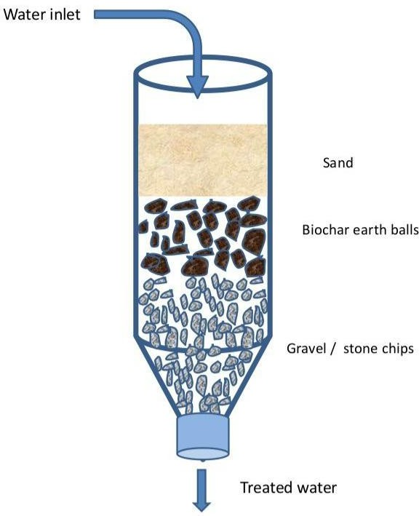

**PROJECT FINAL FABRICATION**

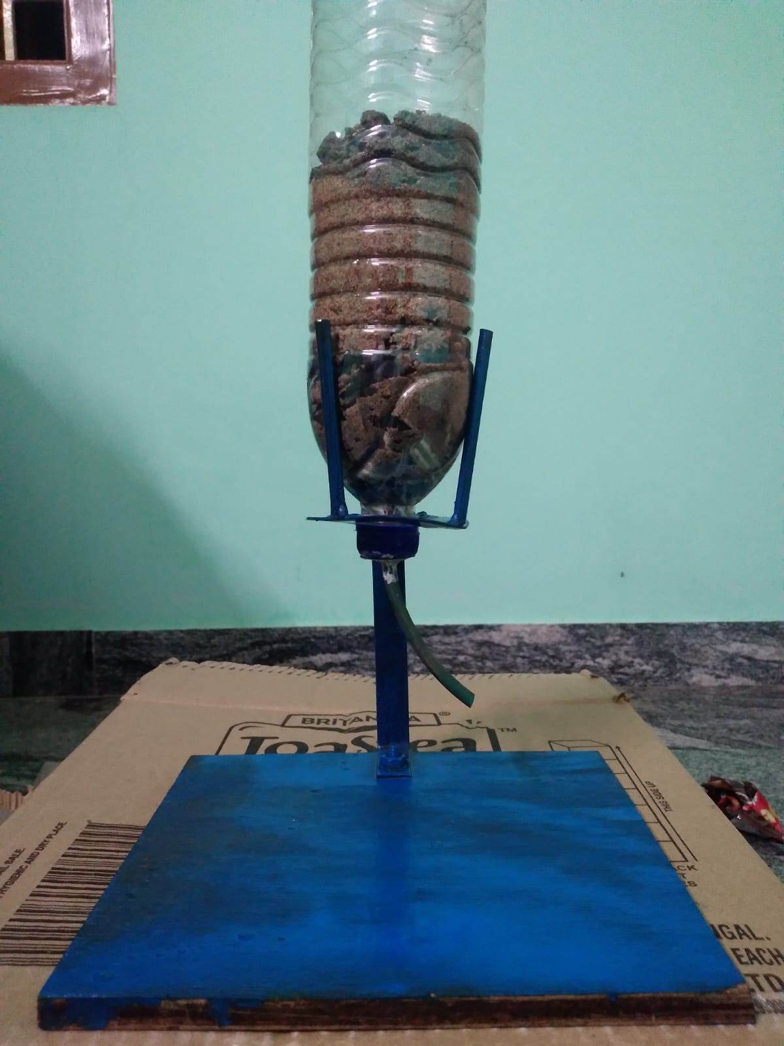

**CHAPTER 6 RESULT AND DISCUSSIONS**

It may also be true that a purifier may be preferred even on a regular basis rather than just emergency situations. This trend is becoming increasingly common in Indian household and institutions irrespective of the water quality which is supplied. However this is not healthy development because this might lead to worsening the quality of supply systems. Nevertheless, Point of Use and Portable water purifiers may find increased application for utilising water from decentralized sources like rain water harvesting, wells, ponds, etc. This study has made an attempt to consider as much diversity as possible in the type of purification methods and products that might be suitable in the framework of portable water purifiers.

**CHAPTER 7 CONCLUSION**

In conclusion, the technology chosen is reliable and meets each of the requirements to a high degree. Though several challenges remain in taking the developed product to a mass-production scale, the template for a possible product and the feasibility of such a system has been amply demonstrated. All told, the proposed system could potentially have a significant and beneficial impact in helping aid workers around the globe obtain clean water where it was previously unavailable.

**COST ESTIMATION**

|  |  |
| --- | --- |
| **PRODUCT** | **COST (in Rs.)** |
| Activated Carbon Balls | 449 |
| River Sand | 200 |
| Gravel | 200 |
| Pebbles | 150 |
| Tap | 150 |
| Water-can | 20 |
| **Total** | **969** |